Title
(Must have a maximum of 15 words and describe, in an engaging manner, the article's main topic and the approach used)

Abstract. Articles must include an abstract (in Spanish) of a maximum of 200 words. It is written in an impersonal mode. The abstract must state the purposes of the study or research, basic procedures (selection of study subjects or laboratory animals; observation and analysis methods), most important findings (providing specific information or data and their statistical significance whenever possible), and the main conclusions. The most novel and relevant observations and aspects of the study should be highlighted. The abstract is written as continuous text, without separating sections with subheadings.

Keywords. A maximum of five keywords, in alphabetical order and separated by semicolons, that precisely describe the article's content. These keywords must be relevant, specific, and preferably included in a thesaurus.

Introduction
It must be brief, clarifying the nature of the research problem studied with its corresponding theoretical support. It must consider the stated hypothesis(es), problem, and justification, with specific, current, and strictly timely (pertinent) bibliographic citations. It concludes with the research objectives and/or by summarizing the article's most relevant findings.

Materials and Methods
Describe the materials, methods, experimental procedure equipment, and statistical methods in sufficient detail to allow other authors to reproduce the results. This section may be organized with subheadings as convenient, but do not use epigraphs or numbering in each subheading. Likewise, the international system of units must be used (the items to be considered in it must be adjusted to the nature of the research). References may be included to describe methods, without transcribing or copying protocols.
Finally, the statistical analysis must be described in sufficient detail to allow readers to access the original information, verify, and replicate the results. Whenever possible, findings shall be quantified and presented with an appropriate indication of the margin of error or reliability (such as confidence intervals, variance, etc.). One must avoid relying solely on statistical hypothesis tests, such as the use of "p" values, as this omits important quantitative information. The choice of research subjects must be justified, randomization detailed, and information provided on possible complications of the intervention, number of observations, and loss of subjects (such as dropouts in a clinical trial).
Whenever possible, references on study design and statistical methods should be from current works (indicating page numbers), rather than from the originals where they were first described. Software programs used must be referenced. In the case of collected or transformed biological material, collection or other permits (according to the current environmental regulations in each country) must be included. Inclusion codes in physical biological collections (herbaria, natural history museums, etc.), and/or online repositories such as Genbank, Mycobank, Bold, IUCN, GBIF, among others, must appear in the body of the document as text, in tables, or with links leading to the mentioned repository.

Results and Discussion
The results shall be presented in logical order, experimental data must be explained briefly and concisely (where appropriate), avoiding the repetition of information presented in tables and figures (these are presented at the end of the "References" section, separating the respective files for the respective figures and tables). The captions for tables and figures are included at the end, separating the respective files for the respective figures and tables.
The discussion must focus on the interpretation of the experimental findings. Do not literally repeat data presented in the introduction or information given in the results. A synthesis comparing the data obtained with the most recent literature. The results and discussion must be presented separately.

Conclusions
This is a separate section from the results and discussion. This section must be based solely on the data presented in the research work, review the main contributions of the project, and should be separated as independent paragraphs. They are written concisely and based on the stated objectives. If warranted, add future perspectives of the research project or review, highlighting the contributions of the published work. It is recommended not to reproduce the conclusions described in the abstract

References
A complete list of all sources cited in the text must be included, following APA style, 7th edition.

Figures
Use only the expression "Figure" in the text (not bold and with its respective consecutive number), including in each case a descriptive caption of the information it intends to illustrate (If the caption is for a composite figure with multiple images, use bold to highlight the letters: A. A-D. B-F.). In the caption, use the expression "Figure" in the descriptive caption (in bold and with a period). All graphs and/or photographs must be included as separate files at the time of submission on the OJS platform. Every figure must be mentioned in the article. Remember that the quality of graphs, photographs, and tables must be high resolution, 300 dpi (minimum), and in .jpg, .png, .tiff, or .bmp format. Attach the figures as separate files in the submission process of your contribution; to do so, choose the "other" option.
In the event that a figure has been previously used in another publication, it is the authors' responsibility to cite the appropriate source, respecting the copyright of any image, map, photograph, etc., that appears in the text.

Examples of figure presentation formats
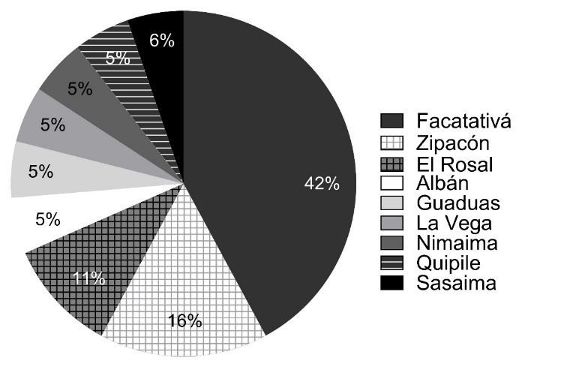

Figure 20. Percentage of PIS executed by VI semester students during technical visits to different production systems in municipalities in Cundinamarca.
Source: Authors' own elaboration.
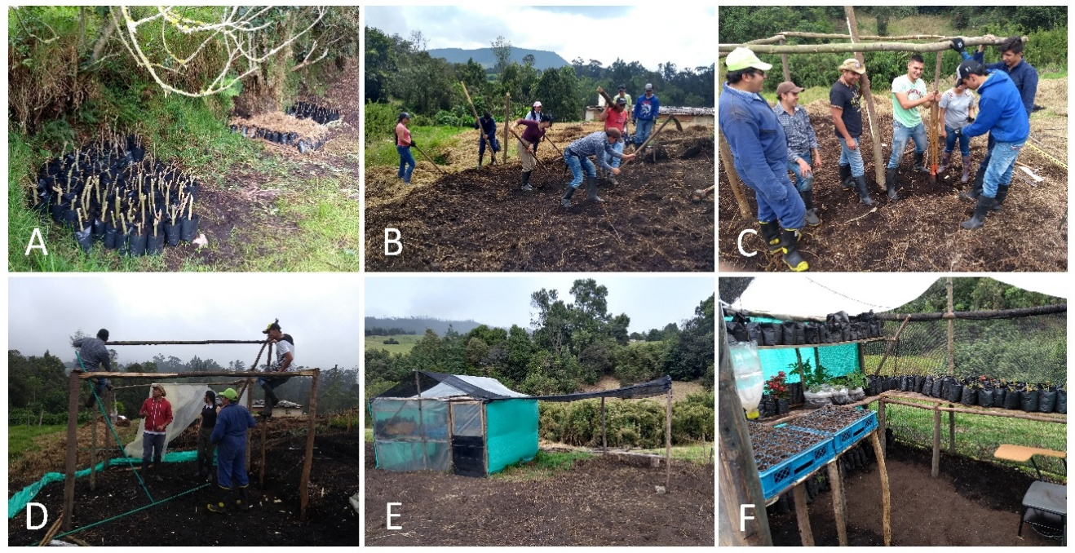

Figure 8. Construction activities for workspaces in learning fields for Propagation and Nursery Production and Crop and Seed Physiology. A. Arrangement of plant material outdoors. B-F. Interior of germination house with seedlings to be propagated and conical seedbeds (blue box with wooden supports).
Source: Hernández-Contreras (2020).

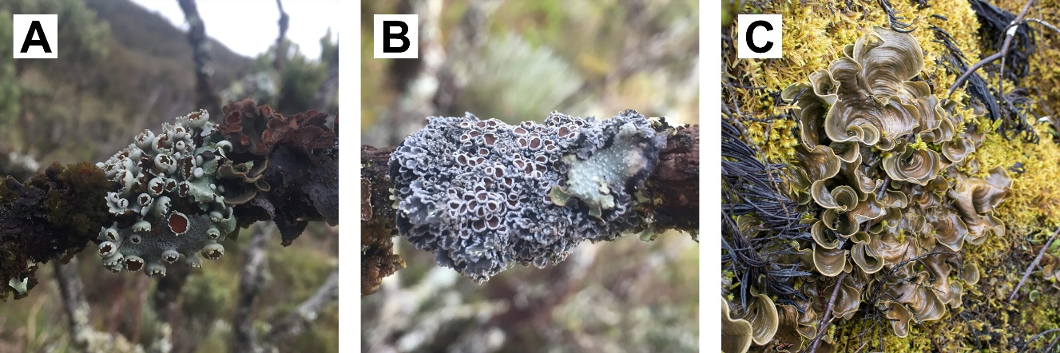

Figure 2. Plant species found in the páramo ecosystem of the Piedras Gordas sector (Chingaza NNP). A. Lobariella parmelioides; B. Pannaria andina; C. Cora pavonia.
Source: Authors' own elaboration.

Tables
Use only the expression "Table" in the text (not bold and with its respective consecutive number), including in each case a descriptive caption of the information presented. Authors must be aware of the journal's size limitations. For this reason, presenting extensive tables should be avoided. If you have a lot of data in a single table, it is recommended to divide it into two or more tables. Tables must be included at the end of the manuscript and in a separate file in Excel (.xls) format. They must be numbered consecutively in the text.
The manuscript must include references to all tables presented. Each table must have a short, explanatory title located at the top of the table. Vertical lines must not be used to separate columns. Consequently, sufficient space must be left between them. Any explanation essential for understanding the table must be presented as a note at the bottom of the table. Column headings must be brief but adequately explanatory.

Example of table presentation format
Table 1. Include here the text or caption that describes the table. Units of measurement are added below the subheadings, as shown in the example, but the meaning of the abbreviation must be explained in the caption, i.e., use: mm = millimeters.

subheading 1 | subheading 2  (mm) | subheading 3  (mm) | subheading 4  (mm)
Variable A | 0.5 | 0.8 | 1.2
Variable B | 1.6 | 0.4 | 0.7
Variable C | 3.1 | 3.5 | 3.3
Variable D | 3.5 | 3.0 | 3.7
Variable F | 7.2 | 2.0 | 4.9

Source: Authors' own elaboration.

